Report
Scientific Mission in Wurzburg

Stay: EP4, Julius-Maximillians-Universität Würzburg
Date: July 2018 (one month)
Mission: Growing SrTiO₃ and Ni:SrTiO₃ thin films by pulsed laser deposition (PLD)
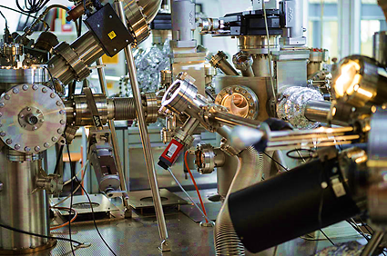
Text: In my project I study the electronic properties of oxides and the effect of doping by TM elements like Ni. In order to do ARPES measurements, one needs crystalline samples. With Prof. R. Claessen and Prof. M. Sing, we got the opportunity to grow SrTiO₃ and Ni:SrTiO₃ thin films by PLD in their laboratory in Wurzburg.
By using 3 different targets of SrTiO₃, Ni_{6%}:SrTiO₃ and Ni_{12%}:SrTiO₃ we tried on the first place to find the good parameters of growth in order to get the quality of films we would like to have. So we started to play with the main parameters; we tried different values for temperature of growth, laser energy and oxygen pressure.
We were measuring the RHEED oscillations at the same time of films deposition. So we could see the formation of every single atomic layer thin film, and control the number of layers we want to grow as well. After the deposition, we sent the samples in-situ to check the LEED patterns and we measured the core levels by XPS.
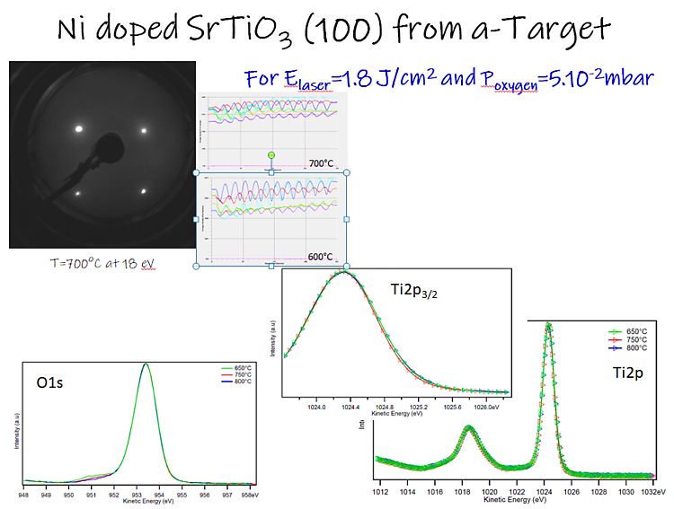
For Ni:SrTiO₃ films, we measured core levels, as well the valence band by XPS. We saw a difference in the VB and we believe that some states related to Ni are appearing near Fermi level in the gap every time the amount of Ni increases in the sample.
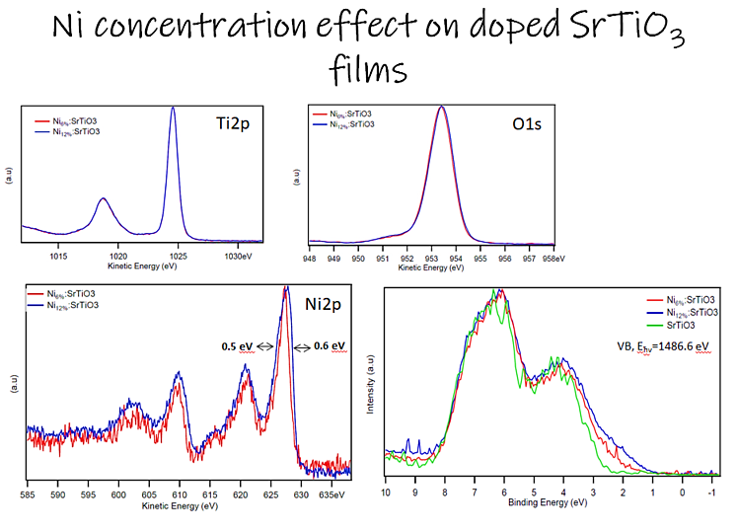
The study and the characterization of the deposited films are still in progress.

